Learn Book Development

Step by step walkthrough to create Learn Book Ionic application

Table of Contents
Softwares Needed 3
Steps for building login page 3
Adding Firebase Analytics Code 9
Adding HTML Pages 10
Final App 14

- Softwares Needed
Make sure the below softwares are already installed in your system and your using open network without any restriction (good bandwidth).
- Node Js – v6.11.2
- Java version Sdk 8
- Cordova and ionic
- Visual Studio code
- Android Studio
- Chrome browser
Please make sure to set JAVA_HOME in environment variables

- Steps for building login page
- Download the starter kit from the given link:
https://github.com/learnBookMaster/starter-kit
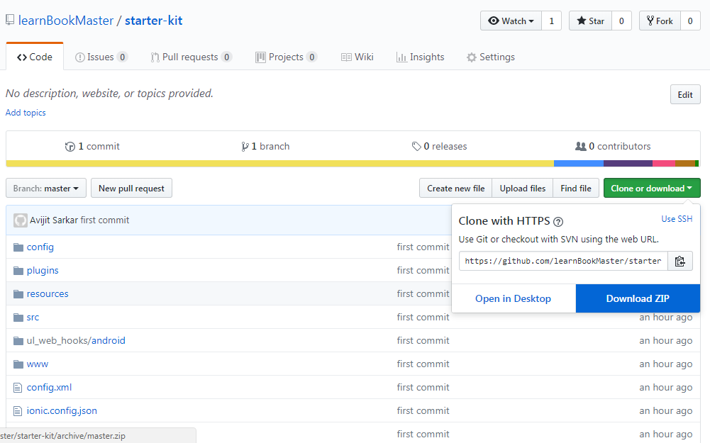

Click on the “Download Zip” option and save it on your preferable location. Once the download completed, go to that directory and unzip the file.

  - Open Command Prompt on your windows machine (open Terminal in mac). Enter the path of the downloaded kit:

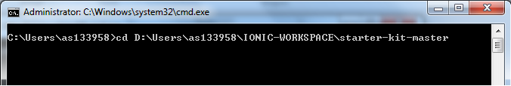

cd <YOUR DOWNLOADED PATH>\starter-kit-master

  - Run command “npm install“ on your command prompt window (open Terminal in mac). It will download all the dependencies required for the application to run successfully. {wait till the command executes completely}

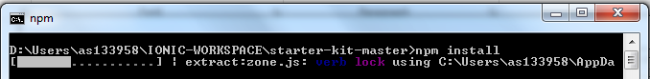

Run command “npm install -g ionic corodva”
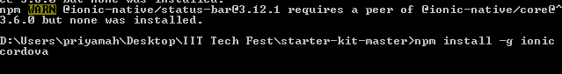
Once the command execution completed, similar output will be shown:
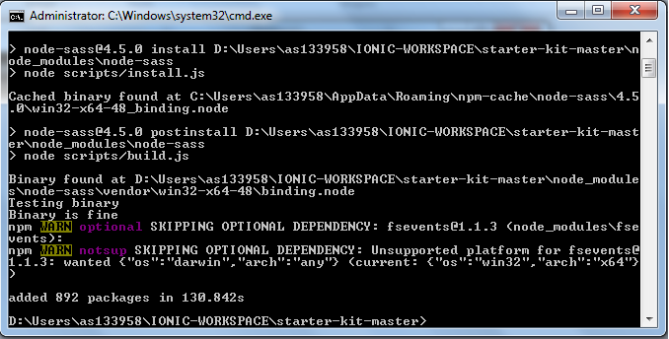
  - Enabling USB debugging in Android Device
Make sure your android device is connected to your system (also the usb debug option of your android device should be enabled). You can do that by going to the “Developer Option” under “Settings”.

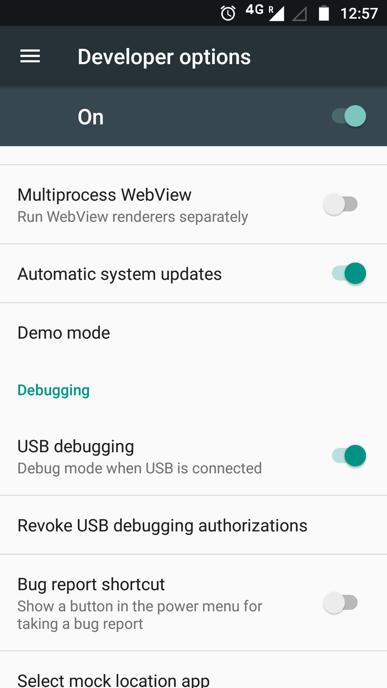

Developer option are not enabled by default on the devices. You have to enable it first. Go to Settings->About Phone->Build number/version (Touch multiple time)

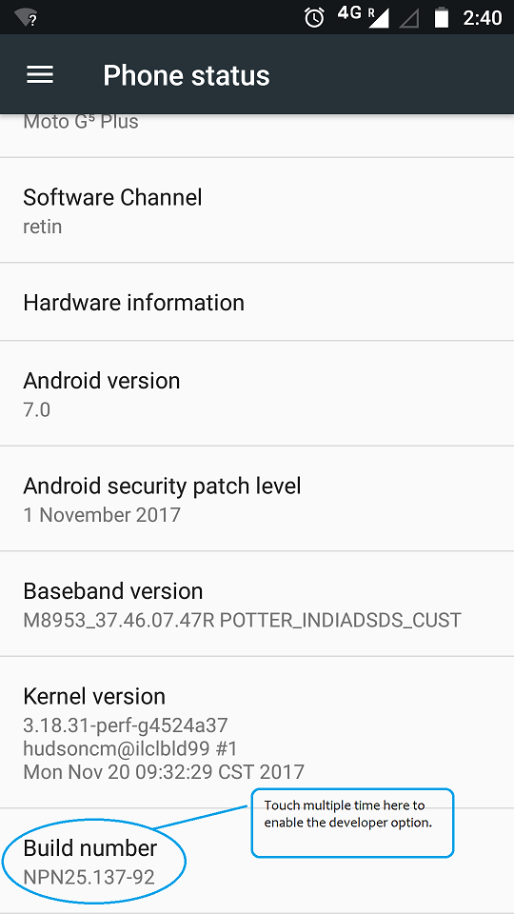

You will be notified once the developer option is enabled.

Note: Even after this if you are unable to enable it, you can simply run the commands below to build the application and transfer the generated apk file to your memory card, and install the application from there.

Generated apk path:
<your project directory>\platforms\android\build\outputs\apk

  - Add command “ionic cordova build android”; after the build is successful add command “ionic cordova run android” (make sure the android device is already connected to your system) check the output.
  - If the output is “Success” the app will run in your device shortly, and you will be able to see an output like below.

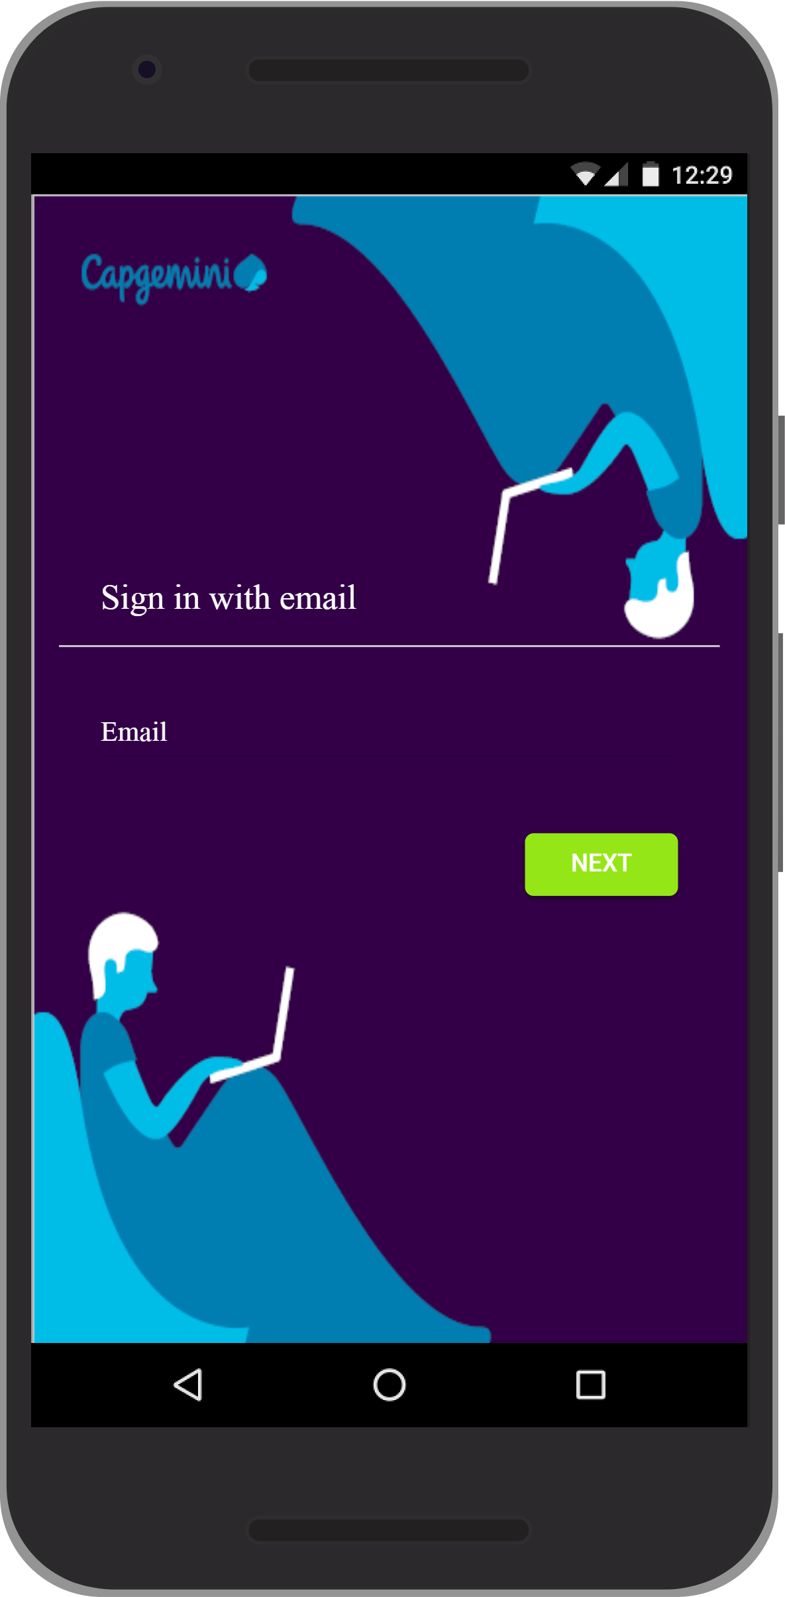

  - There is also an option of opening and running the app in Android Studio. Open Android Studio. Click on “file Open” and select the below path:

<< project folder/platforms/android >>

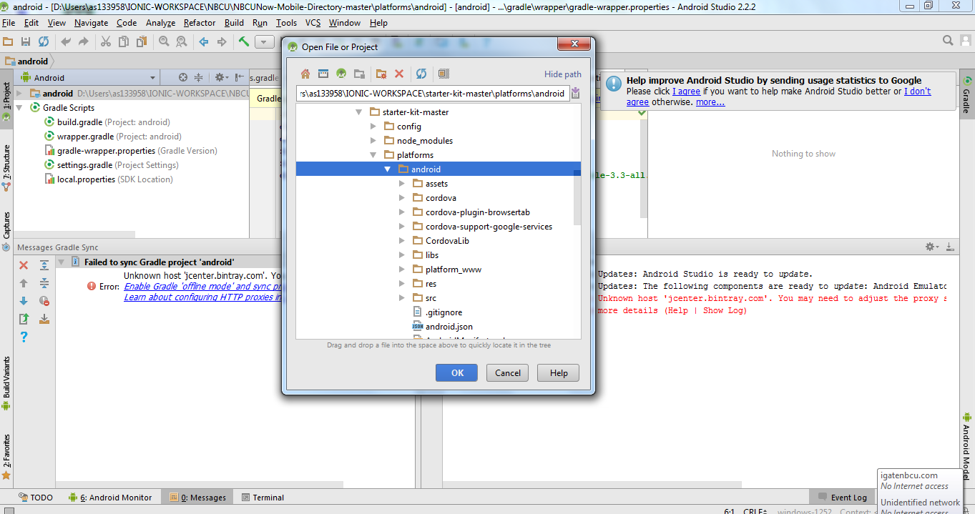

- Once open click on the green play icon in the Android studio” (make sure the android device is already connected to your system) (attach screenshot of showing mobile run)
- Display the final output page

- Adding Firebase Analytics Code:
- Now as the application is running perfectly, we will be adding some code. For the same please open your project in Visual Studio Code.
- Now open “login.ts” file from /src/pages/login folder, and add the below snippets inside “signInSuccess” block of “getUiConfig” function.

this.firebaseAnalytics.logEvent('loginPage', {userName: currentUser.displayName})
.then((res: any) => console.log(res))
.catch((error: any) => console.error(error));

Please refer to the screen-shot below:

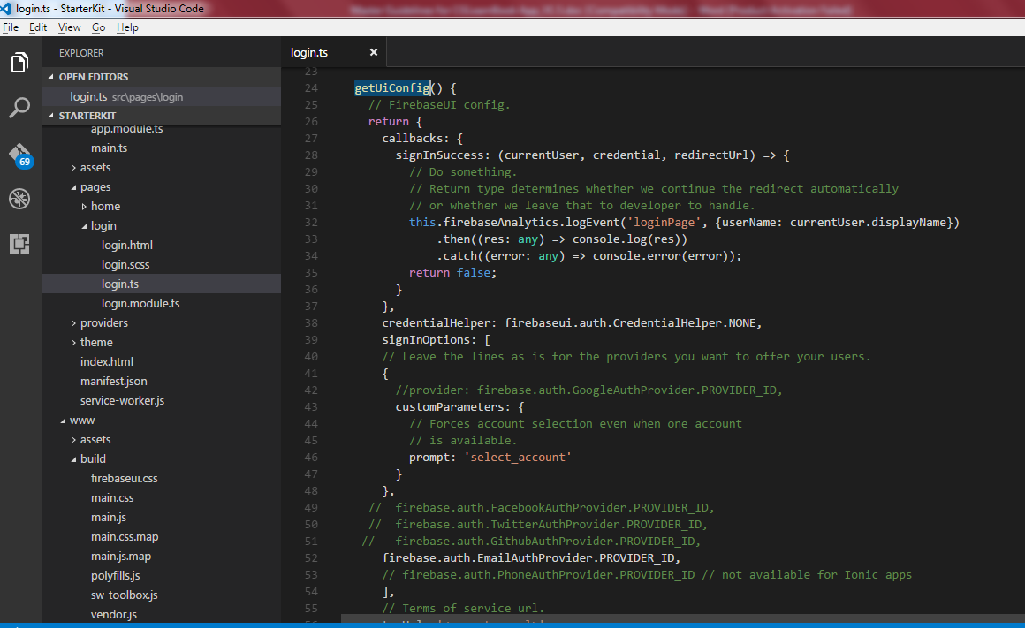

- Please check line #32 - #34 on the above screen-shot.
- Now you can run the application again (following the same steps you did before), to submit data to firebase analytics.

- Adding HTML Pages:
    - Download all the pages from the below link:
https://github.com/learnBookMaster/html-pages
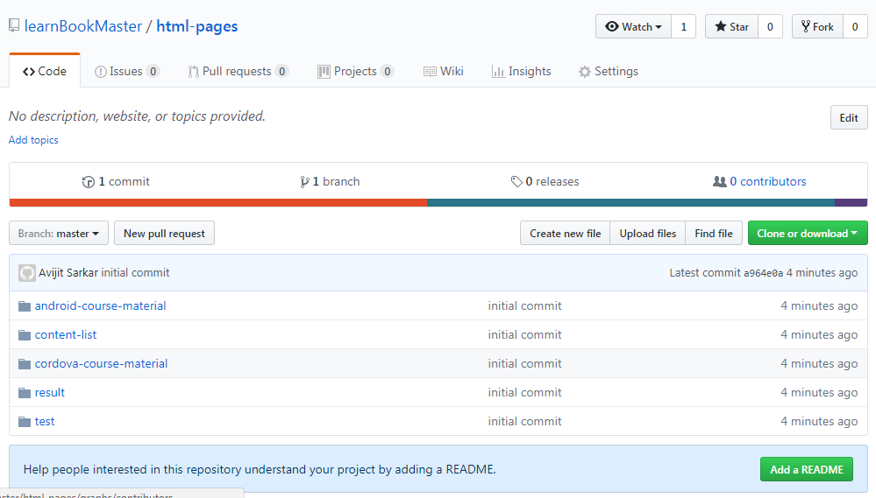
    - Once the download complete paste all the folders inside your /src/pages directory.
    - Open your “/src/app/app.module.ts” file and remove the comments
Commented code

/*
import { ContentListPage } from '../pages/content-list/content-list';
import { AndroidCourseMaterialPage } from '../pages/android-course-material/android-course-material';
import { CordovaCourseMaterialPage } from '../pages/cordova-course-material/cordova-course-material';
import { TestPage } from '../pages/test/test';
import { ResultPage } from '../pages/result/result';
*/

    - After removing comments Code (/* */)
import { ContentListPage } from '../pages/content-list/content-list';
import { AndroidCourseMaterialPage } from '../pages/android-course-material/android-course-material';
import { CordovaCourseMaterialPage } from '../pages/cordova-course-material/cordova-course-material';
import { TestPage } from '../pages/test/test';
import { ResultPage } from '../pages/result/result';
- Also remove comment on all those components inside “declarations” & entryComponents”:
Before :
declarations: [
MyApp,
LoginPage
//,ContentListPage,
//AndroidCourseMaterialPage,
//CordovaCourseMaterialPage,
//TestPage,
//ResultPage
],

entryComponents: [
MyApp,
LoginPage
//,ContentListPage,
//AndroidCourseMaterialPage,
//CordovaCourseMaterialPage,
//TestPage,
//ResultPage
],

After Removing code:
declarations: [
MyApp,
LoginPage,
ContentListPage,
AndroidCourseMaterialPage,
CordovaCourseMaterialPage,
TestPage,
ResultPage
],

entryComponents: [
MyApp,
LoginPage,
ContentListPage,
AndroidCourseMaterialPage,
CordovaCourseMaterialPage,
TestPage,
ResultPage
],

- Open Home.ts file (/src/pages/home) and uncomment the following
//import { ContentListPage } from '../content-list/content-list'; //comment code
// this.navCtrl.setRoot(ContentListPage,{topic: topic}); //comment code

- Open home.html file
  - Uncomment following code
<!--< ion-header>
<ion-navbar>
<ion-title>
LearnBook
</ion-title>
<ion-buttons end>
<button ion-button icon-only small (click)="logout()">
<ion-icon name='log-out'></ion-icon>
</button>
</ion-buttons>
</ion-navbar>
</ion-header>
<ion-content padding>
<ion-card *ngFor="let topic of topics">
<ion-item>
<h2>{{topic.title}}</h2>
<p>{{topic.para1}}</p>
</ion-item>
<img src="{{topic.iconUrl}}">
<ion-card-content>
<p>{{topic.desc}}</p>
</ion-card-content>
<ion-row>
<ion-col col-3>
<button ion-button (click)="startCourse(topic.title)">
Start
</button>
</ion-col>
<ion-col col-3>
<button ion-button icon-left clear>
<ion-icon name="alert" style="color:#ff304c;" *ngIf="topic.marksObtained<50"></ion-icon>
<ion-icon name="checkmark-circle" style="color:#95e616;" *ngIf="topic.marksObtained>=50"></ion-icon>
<div>{{topic.marksObtained}}%</div>
</button>
</ion-col>
<ion-col col-6>
<button ion-button icon-left clear>
<ion-icon name="clock"></ion-icon>
<div>{{topic.timeSpent}}</div>
</button>
</ion-col>
</ion-row>
</ion-card>
</ion-content>
--></ion-content>

  - Comment/remove following code
ion-header>
<ion-navbar>
<ion-title>Home</ion-title>
</ion-navbar>
</ion-header>
<ion-content padding>
<h2 > <font color="white">Welcome </font> </h2>
<button ion-button (click)="logout()">
Log out
</button>
</ion-content>

- Final App
Save all the files, you can now build again and re-run the application on the device to see the changes. After successful login into the application using your registered email (what you have done in earlier steps, if not you can register for a new account) you will be able to see the Learn Book now as shown below:

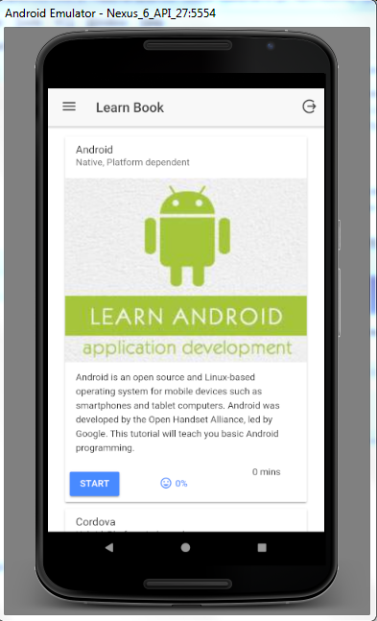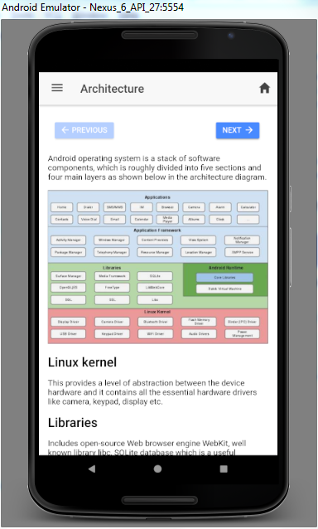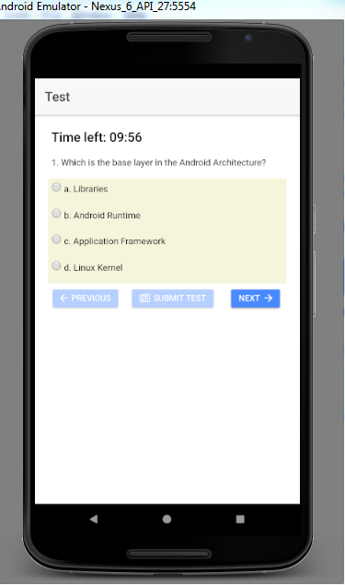

End of Document
About Capgemini
A global leader in consulting, technology services and digital transformation, Capgemini is at the forefront of innovation to address the entire breadth of clients’ opportunities in the evolving world of cloud, digital and platforms. Building on its strong 50-year heritage and deep industry-specific expertise, Capgemini enables organizations to realize their business ambitions through an array of services from strategy to operations. Capgemini is driven by the conviction that the business value of technology comes from and through people. It is a multicultural company of 200,000 team members in over 40 countries. The Group reported 2016 global revenues of EUR 12.5 billion.
Learn more about us at www.capgemini.com

This message contains information that may be privileged or confidential and is the property of the Capgemini Group.
Copyright © 2017 Capgemini. All rights reserved.

